18

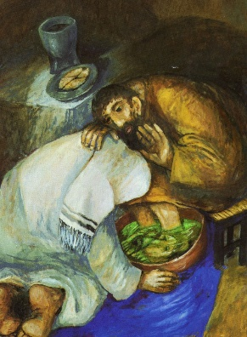
Apostolic Community
is a community of brothers who serve
Before the meeting
Prepare the place where the community is going to meet. Ask those who will participate in the meeting to bring a symbol of service. Begin with a song highlighting the value of service, of mutual love, of forgiveness, etc.
The word of God
I, then, a prisoner for the Lord, urge you to live in a manner worthy of the call you have received, with all humility and gentleness, with patience, bearing with one another through love, striving to preserve the unity of the spirit through the bond of peace: one body and one Spirit, as you were also called to the one hope of your call; one Lord, one faith, one baptism; one God and Father of all, who is over all and through all and in all. (Eph 4:1-6)
Stop lying to one another, since you have taken off the old self with its practices and have put on the new self, which is being renewed, for knowledge, in the image of its creator. Here there is not Greek and Jew, circumcision and uncircumcision, barbarian, Scythian, slave, free; but Christ is all and in all. Put on then, as God's chosen ones, holy and beloved, heartfelt compassion, kindness, humility, gentleness, and patience, bearing with one another and forgiving one another, if one has a grievance against another; as the Lord has forgiven you, so must you also do. And over all these put on love, that is, the bond of perfection. And let the peace of Christ control your hearts, the peace into which you were also called in one body. And be thankful. Let the word of Christ dwell in you richly, as in all wisdom you teach and admonish one another, singing psalms, hymns, and spiritual songs with gratitude in your hearts to God. And whatever you do, in word or in deed, do everything in the name of the Lord Jesus, giving thanks to God the Father through him. (Col 3:9-17)
(Other texts may be chosen, like the washing of the feet, etc.)
From our Constitutions and Rules
A spirit of simplicity and joyfulness marks our communities. In sharing what we are and what we have with one another, we find acceptance and support. Each of us offers his friendship and places his God-given talents at the service of all. This enriches our spiritual life, our intellectual development and our apostolic activity. In humility and with the strength of charity, we express our responsibility for each other in fraternal correction and forgiveness. (C 39)
From the writings of Eugene de Mazenod
They will bear with one another in much patience and meekness, and strive to outdo one another in rendering service and joyfully practicing charity. Each will avoid whatever may wound his brothers and will gladly yield to the wishes of others, so that the peace of God and the charity of Christ may abide in them. They will love each other and show mutual respect and deference for one another. (Rule of 1826)
A commentary
Simplicity and joyfulness should characterize a community brought together not by external compulsion but by the sharing of the same Faith and the same ideals. “And day by day, attending the temple together and breaking bread in their homes, they partook of food with glad and generous hearts, praising God and having favour with all the people” (Acts 2:46-47). This fraternal sharing is not merely of what we have, but above all of what we are. “The company of those who believed were of one heart and one soul… they had everything in common” (Acts 4:32). Similarly, the variety of gifts among the members should serve the common cause and strengthen unity (1Cor 12:4-11).
As witnessing to the messianic community, our Oblate communities should be characterized by the Kingdom values. Whereas ambition, pride and lack of forgiveness mar the joy and simplicity of a life lived in Christ (Matthew 20:24-28), the forgiveness of God belonged to the list of messianic riches (Jer. 31:34; Ezek. 36:25-33). This messianic forgiveness was linked to the gift of the Spirit (Ezek. 36:27; Jn 20:19-23). Our communities called to bear witness to the presence of God’s Kingdom in our midst should therefore be forgiving communities and bearers of God’s forgiveness (Luke 17:3-4).
We must have confidence in community life. It is the atmosphere of life that God wants for us Religious. Hence we should take positive and practical steps to build community: Community as an environment or atmosphere in which we live is much more important and meaningful to our lives than institutional structures of systems. Man is the end of institutions. Relationships keep people together much more than systems or structures. In fact, without true relationships, no institution can stand for long. Hence it is important that everyone in community be respected, accepted and loved. No one should be written off as beyond care and love.
Today, as perhaps never before, many religious are asking, “Why can’t we care for one another as well as we seem to care for those to whom we minister?” Do we take one another for granted? Have our communities become no more than places out of whom we work for others while ignoring our mutual needs? We have become more aware of the various good and necessary needs of the emotional side of our being. We need to love and be loved, to affirm and to be affirmed. These are not needs that disappear when we answer the call, to discipleship and religious life and ministry. In fact, that very call is one that also invites us to grow and mature in all aspects of our person, and such growth cannot take place without that kind of concern and interaction that will allow us to both express our needs and use our gifts in the trusting climate of community. We need to share both our faith and our doubts, our joys and our sorrows, our loneliness and the fruits of solitude. We need to appreciate the growth patterns and their critical passages in ourselves and in others; to learn that it is good to receive as well as to give. Each of us is an inner world of mystery, to draw the water of life from the well, so we can offer these riches that God has given each of us to those whom we serve. The very efficacy, power and spirit of our ministry will be in proportion to the growth we experience in the context of our caring communities.
Our communities should therefore be living Christian cells, a mini-realization of the Kingdom of God. The Gospel values should shine in our communities through a genuine sharing of goods (poverty), through a genuine out-going love (chastity) and through a genuine search for God’s will in our regard in collaboration with our superiors (obedience).
From Sullivan-Haslam, Praying with our Constitutions, p. 149-150
Pause for reflection
It may now be good to invite those present to pause for a few minutes, in meditation of what has been read and preparing to share their own experience.
Sharing
The animator of the meeting may now invite those present to share their experience around the theme of community as a place where we are called to love one another through concrete and visible gestures of service.
Here are a few points that can guide and help the sharing.
- What has been your experience of community from the day you joined the Oblates? In the formation houses where you were formed, in the apostolic communities where you worked and in the one to which you now belong?
- What are the gifts you received from God that you would like to put at the service of your brothers within the community?
- What were the main obstacles or difficulties that you went through in your experiences of community life?
- Is there a suggestion you would like to make in order to improve the quality of your community life, the quality of the different kinds of relationships within the community?
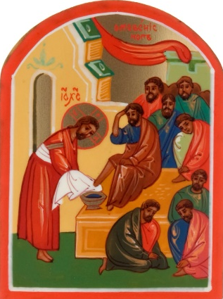
- Any other point you would like to share, related to the theme of the meeting.
Common spontaneous prayer
The animator may now invite to turn the sharing and the listening into a spontaneous prayer. He may begin, just to set the tone of the prayer and to help others, especially those who are not used to praying out loud or in public, to formulate their own prayer.
Concluding song
It may be a song that takes up a theme that has come out during the meeting, a song to our Lady as the handmaid of the Lord, or any other song that helps the community tighten the bonds of love, friendship and unity.

