10

The community of the first Christians
Setting
Gather around a table where a candle is lit. A symbol to indicate togetherness can be kept on the table., e.g. A basket of flowers.
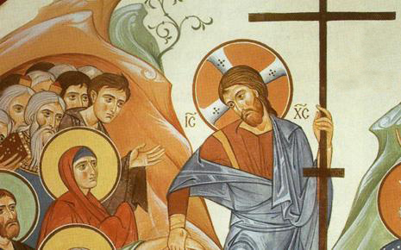
Hymn
Motivation
Family is the basic community where we all learn to share life and all that it offers. For us Oblates, community is our family where we share not only our lives but also our faith. The first Christian community was a faith sharing community. Let us go back to the Holy Scriptures to be inspired by their life witness.
The Word of God (Acts of the Apostles 2:42-47)
And they devoted themselves to the apostles’ teaching and the fellowship, to the breaking of bread and the prayers. And awe came upon every soul, and many wonders and signs were being done through the apostles. And all who believed were together and had all things in common. And they were selling their possessions and belongings and distributing the proceeds to all, as any had need. And day by day, attending the temple together and breaking bread in their homes, they received their food with glad and generous hearts, praising God and having favour with all the people. And the Lord added to their number day by day those who were being saved.
Texts for Reflection
At the start, on the one hand, the community did not have a well-defined structure; while, on the other, the value of communion that should animate it was clear. The house of Aix, “in my mind and my hopes, must reproduce the perfection of the first disciples of the Apostles – that of the first Christians in Jerusalem. I base my hopes on that much more than eloquent discourses. Have they ever converted anyone?” (Eugene de Mazenod, Letter to Tempier, November 15, 1815)
The first Christians are a model of community life. They teach us what living together in faith is all about. It was nothing but their unwavering faith in Christ Jesus which led them to give up even the things and possessions they considered dear to themselves.
Delayed in Paris because of the affairs of the Congregation, his pain of being separated from the community was so great that Eugene wrote to Fr. Tempier: “I am bored when separated from you and pine for my return. Nothing on earth is worth being kept from dwelling pleasantly in our holy house with such good brothers as yourselves. Never have I appreciated so much quam dulce et quam jucundum habitare fratres in unum (Ps 132). This strikes me all the more in that I see with my own eyes that it is not given to all communities to taste this happiness, harder to find than one thinks in this world below” (Selected Texts, 301).
Community – one of the three 1972 General Chapter documents – says: “Community should signify a web of relationships within which we are «at home». This means that we are accepted as we are. The charity of which we speak as the bond of community is scarcely charity if it remains cold, distant and intermittent, always questioning, and nearly always criticizing. Is acceptance really present if all effective sharing is perpetually banished from among us? Although a healthy measure of privacy is necessary, are not many today seeking a degree of human sharing that goes beyond mere sociability? Many seek the type of relationships which are going to support them in their difficulties, challenge them in their convictions, forgive them in their faults and provide that measure of opposition that alone brings out that which is most authentic” (Community, art. 13).
Moment of silence
Faith Sharing
Think a minute:
“If we have no peace, it is because we have forgotten that we belong to each other.” (Mother Teresa)
We wish to choose men who will have the will and courage to walk in the footsteps of the Apostles. (De Mazenod to Tempier: October 9, 1815)
What is the binding force in our communities? Should it not be our faith in Jesus that binds us together in spite of our differences?
Intention for our common prayer
– that our communities may grow in real fellowship, charity and love following the footsteps of the first Christians who bore witness to their faith in Jesus Christ by responding willingly to the needs of the community. We pray to the Lord.
– that our congregation may be sign of contradiction to the world by sharing the same charism wherever we are, that unity in diversity is a possibility. We pray to the Lord.
– that the world leaders may work hand in hand to bring an end to the civil wars and bring peaceful solutions to the people who have lost their very right to life in such dire conditions. We pray to the Lord.
Commitment
The model for the life of the Missionaries was that of the apostles around Jesus. In his invitation to Tempier to join him, Eugene used the expression that he was looking for men who had “the will and the courage to walk in the footsteps of the apostles.” It struck a chord in the heart of Tempier who generously replied affirmatively to the invitation, by using the same apostolic vocabulary. Eugene’s response to this generosity was to tell him how necessary he was to ensure the regularity of the house which, in his mind and his hopes, had to reproduce the perfection of the first disciples of the apostles on which “I base my hopes on that much more than on eloquent discourses. Have they ever converted anyone?” A month later Eugene again spoke to Tempier about the necessity of being apostolic men so as to win people for God. (F. Santucci, OMI, Eugene de Mazenod, co-operator of Christ the Saviour, communicates his Spirit, Rome 2004, p. 84)

Final Prayer
O God, You Who are perfect Unity, and Supreme Love
make us to be of one heart and one soul
so that our community, built up in accord
and solidly based on the confession of the truth
may enjoy the gifts of unity and peace.
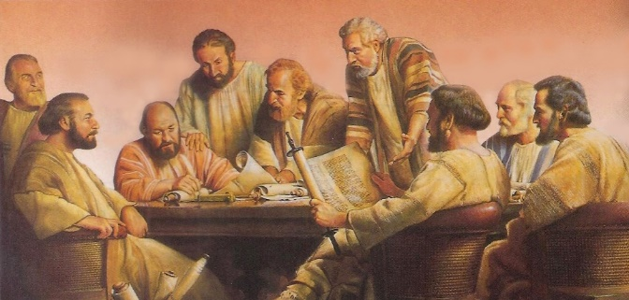
Through Our Lord Jesus Christ your Son, who lives and reigns with you in the unity of the Holy Spirit, one God for ever and ever. Amen
Blessing
and Song
(Bind us
together Lord!)

