December 8th, Feast of the Immaculate Conception

The Second Year of our Oblate Triennium: Formation and our Vow of Poverty

Mary Immaculate: mother of the poor (anawim)

SETTING
The animator of the encounter arranges the ambience so that all may be comfortably seated in a circle to facilitate prayer and discussion. A candle, the Bible, an Oblate Cross may be placed in the center of the community.
MOTIVATION
In this encounter we gather to share about how we look on Mary and how she guides us in formation and poverty. As Oblates of Mary Immaculate, we look to Mary’s example in living our vow of poverty through ‘emptiness’, ‘selflessness’, ‘letting go’ and ‘helplessness. Mary’s helplessness as she stood in front of the crucified Lord, became strength where she accompanied Christ until the last moment to fulfil the mission of God. Mary was able to perform this great act because she ‘emptied herself’ to assist her Son to fulfil His heavenly Father’s mission.
SONG:
PRAYER

THE WORD OF GOD: GOSPEL OF LUKE 1:39-56
During those days Mary set out and traveled to the hill country in haste to a town of Judah, where she entered the house of Zechariah and greeted Elizabeth. When Elizabeth heard Mary’s greeting, the infant leaped in her womb, and Elizabeth, filled with the holy Spirit, cried out in a loud voice and said, “Most blessed are you among women, and blessed is the fruit of your womb. And how does this happen to me that the mother of my Lord should come to me? For at the moment the sound of your greeting reached my ears, the infant in my womb leaped for joy. Blessed are you who believed that what was spoken to you by the Lord would be fulfilled.” And Mary said: “My soul proclaims the greatness of the Lord; my spirit rejoices in God my savior. For he has looked upon his handmaid’s lowliness; behold, from now on will all ages call me blessed. The Mighty One has done great things for me, and holy is his name. His mercy is from age to age to those who fear him. He has shown might with his arm, dispersed the arrogant of mind and heart. He has thrown down the rulers from their thrones but lifted up the lowly. The hungry he has filled with good things; the rich he has sent away empty. He has helped Israel his servant, remembering his mercy, according to his promise to our fathers, to Abraham and to his descendants forever.” Mary remained with her about three months and then returned to her home.
TIME FOR SILENT REFLECTION

RESPONSE TO GOD’S WORD: Psalm
OBLATE TEXTS:

OMI Constitution 10
Mary Immaculate is patroness of our Congregation. Open to the Spirit, she consecrated herself totally as lowly handmaid to the person and work of the Saviour. She received Christ in order to share him with all the world, whose hope he is. In her, we recognize the model of the Church's faith and of our own.
We shall always look on her as our mother. In the joys and sorrows of our missionary life, we feel close to her who is the Mother of Mercy. Wherever our ministry takes us, we will strive to instil genuine devotion to the Immaculate Virgin who prefigures God's final victory over all evil.

2010 General Chapter Calls
“Formation” #8
Conversion in formation requires a clear program for ongoing formation in every Unit. That each Oblate be constantly renewed in the knowledge of the Scriptures for the good of the mission. For this purpose, Oblates are invited to avail of the “Centre De Mazenod” Aix programs for renewal in the Oblate Charism and family.

GOING DEEPER INTO THE THEME
Dictionary of Oblate Values, “Poverty”, Olegario Dominguez, omi
3. Our poverty bears a specifically Marian stamp. Mary was the example par excellence of "the poor and humble of the Lord who confidently hoped for and receive salvation from him". She is also the one who lived, in the deepest and most unique communion, the mystery of the Savior's self-effacement. In her, the happiness promised to the poor reached its climax because the Lord looked upon the lowliness of his servant. That is why all generations will call her blessed. "Mother of the poor, the humble and the simple", it is she who should inspire our attitude of compassionate "maternal" association with the poor of our world. We must implant in their hearts hope in a liberating God.

Lèo Deschâtelets,OMI, Notre vocation et notre vie d’union intime avec Marie Immaculée, Circulaire 191, 1951.
This spirit of oblation of our religious, priestly, missionary and apostolic life to God's infinite love, in Jesus Christ our Savior, for the most merciful ministry toward poor souls, will be achieved through Mary Immaculate, Mother and Patron to whom we must nurture a singular devotion “peculiaris devotio” (art. 221). We are Oblates of Mary Immaculate. This is not only a title. The name defines us just as the name of Priests of the Blessed Sacrament indicates a family of priests specially devoted to the worship of the Sacrament of the Eucharist, or as the Marian Fathers also indicates a Community of priests dedicated to the cult of Mary. We could multiply examples, and each of you could do the same. Before explaining further what that entails, we affirm that we are Oblates of Mary Immaculate in the strictest sense of the word. It is through Her that we will be Oblates of souls, Oblates of Jesus Christ, Oblates of divine charity.
We cannot be true Missionary Oblates of Mary Immaculate without putting into our souls all that we have described and especially without living it fully with Her: “Sentire cum Maria”. It is not a question -- if we are to understand our vocation -- of having an conventional devotion for Mary Immaculate. It is a kind of identification with Mary Immaculate; it is a gift of ourselves to God through Her and like Her, which goes to the very foundation of all our Christian, religious, missionary and priestly life. (...)
There is no doubt, however, that the Oblates have had, since the origin of the Institute, a great devotion to Mary Immaculate. Article 257, so rich in meaning, which dates from the early days, is there to prove it. We first mention (...) “... dulcem ... Mariam peculiaris prosequentur devotionis affecta, ac semper in Matrem habebunt”. Article 258, also very important, goes back to the early days of the Congregation and leaves no doubt about the feelings of our Elders, “Ideo quotidie coronam Virginis recitabunt and omnem navabunt operam, quo populi Immaculatam et Sanctissimam Deiparam ferventius fiducialiusque colant”.
SHARING OUR FAITH:
The animator invites each Oblate present to share what has inspired him in the reflection and around the questions:
At the Annunciation the Angel Gabriel said to Mary ‘nothing is impossible for God’…. Then Mary said ‘I am the handmaid of the Lord let it be done to me according to your will’. What does this say to you, your life of faith?
What has been your relationship with Mary before joining the Oblates? You may also go back to your infancy years, to your family experience, maybe a recollection of your first experiences about Mary.
What has been your relationship with Mary within the Oblate life and family? You may want to share how you live such relationship today, maybe telling a story, an experience…Perhaps Mary has helped you to grow in appreciation of poverty and simplicity of spirit.
Could you share an experience where you felt in a special way the presence of Mary in your life? Or an experience where through your love for Mary or through Mary herself you were able to be more in solidarity with the poor?
Anything else you would like to share about the theme of this faith sharing session?

COMMITMENT:
The animator reminds everyone that we are preparing for the Triennium by seeing how we can open ourselves to God’s grace to grow, change, be transformed. We are asked to consider a concrete gesture in the life of our community as a sign of conversion. Let us ask God to inspire us, help us be bold and courageous so that during these weeks and months of preparation we will commit ourselves to some real sign of new life among us.
What might be a gesture of conversion we are called to hear related to our devotion to Mary with her poverty of spirit and total dependence on God’s will?

A TIME FOR PRAYER AND THANKSGIVING / INTENTIONS
FINAL PRAYER:
Close to Saint Eugene’s heart was the prayer:
“You are beautiful, O Mary.”(In Latin, Tota pulchra est”) See p. 43 in the book of Oblate Prayer.
V/ All fair are you, O Mary!
R/ All fair are you, O Mary!
V/ The original stain is not in you!
R/ The original stain is not in you!
V/ You are the glory of Jerusalem!
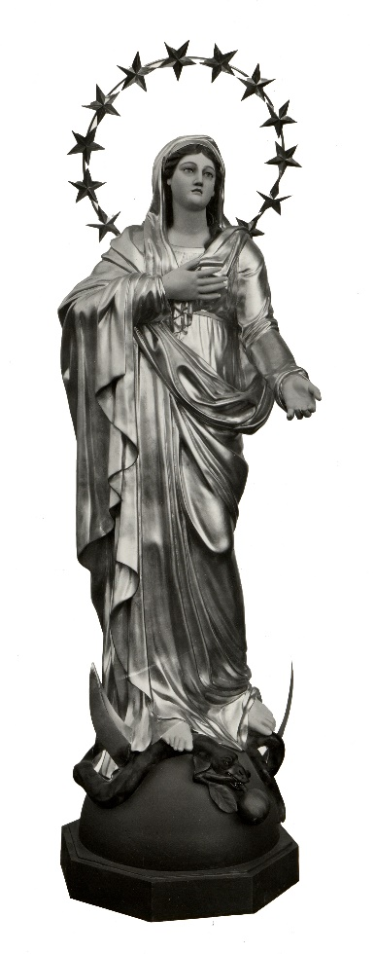
R/ You are the joy of Israel!
V/ You are the honor of your people!
R/ You are the advocate of sinners!
V/ O Mary!
R/ O Mary!
V/ Most prudent Virgin!
R/ Most loving Mother!
V/ Pray for us!
R/ Intercede for us
with our Lord, Jesus Christ!

BLESSING AND SONG:
The animator asks an Oblate present to pray a blessing over the group and then all sing the final song:
Salve Regina

