11.

Mary Immaculate is
Mother of the Apostolic Community
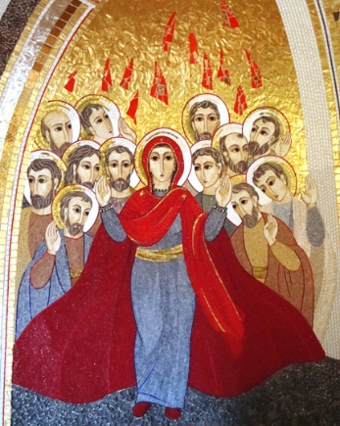
Before the meeting
Prepare the place where the community is going to meet. Put on a well prepared table an image of Mary, or a Rosary, or a symbol related to Mary. Begin with a song either to the Holy Spirit or to Mary (better if the song combines both).
The word of God (Act 1:12-14)
Then they returned to Jerusalem from the mount called Olivet, which is near Jerusalem, a Sabbath day’s journey away. And when they had entered, they went up to the upper room, where they were staying; that is, Peter and John and James and Andrew, Philip and Thomas, Bartholomew and Matthew, James the son of Alphaeus, and Simon the Zealot, and Judas the son of James. These all with one mind were continually devoting themselves to prayer, along with the women, and Mary the mother of Jesus, and with His brothers.
From our Constitutions and Rules
Mary Immaculate is patroness of our Congregation. Open to the Spirit, she consecrated herself totally as lowly handmaid to the person and work of the Saviour. She received Christ in order to share him with all the world, whose hope he is. In her, we recognize the model of the Church’s faith and of our own.
We shall always look on her as our mother. In the joys and sorrows of our missionary life, we feel close to her who is the Mother of Mercy. Wherever our ministry takes us, we will strive to instil genuine devotion to the Immaculate Virgin who prefigures God’s final victory over all evil. (C 10)
From the writings of Eugene de Mazenod
After that which directly concerns God, nothing is more precious for truly enlightened piety than that which concerns the honour of the Blessed Virgin Mary. Here we meet all that exists in a son towards his mother. And what a Mother! She has given us him who is the world’s life and salvation, she has engendered all of us spiritually at the foot of the Cross through the pangs of the passion and death of the God- Man, the blessed fruit of her womb; she is rightly called the new Eve and the co-redemptrix of the human race. Her tenderness watches over us. She nourishes our souls with divine favours which, as the holy Fathers say, she dispenses. From heaven above she distributes them generously to her children, after having drawn them for their sake from the heart of her divine Son, our Saviour. Even our earthly existence is under the protection of her maternal love; and the Angels, who forever praise and always obey her as their Queen, are sent from her throne to guide us on our way (Ps. 91:11)… God’s own glory is enhanced by Mary’s. Everything that tends to glorify the Blessed Virgin on our part, relays from her to God, acquiring so to speak, in the hands of the most perfect of creatures, the character of the most perfect homage towards the Creator. Yes, we thus glorify God in the masterpiece of his power and glory; we praise him because among all the marvels of power that prove his infinite greatness, he has produced someone who sums up in herself alone, better than all other persons put together, his adorable perfections. Furthermore, the greatness of the Blessed Virgin consists especially in her dignity as Mother of God. This is the reason for all the prerogatives with which she is endowed and for the superior cult we pay her. Thus it is the Son whom we honour in the person of the Mother and this is why, in our homage to Mary, it is impossible to overstep the limit, provided we consider her a creature, because God then always remains the supreme end of all this homage.
(Pastoral Letter, July 8, 1849)
Other Selected Texts: 78, 98-109, 111, 184-187, 191, 295, 392, 394, 452, 515, 517
A commentary
To be “patroness of our Congregation” means that Mary Immaculate is at one and the same time the one who protects and keeps us, who intercedes for us in a special way in the presence of her Son, and who also serves us as a model and an inspiration. Article 10 particularly insists on this latter aspect: Mary is the model of our oblation, of our missionary zeal, of our faith. a. The model of our oblation. “Open to the Spirit, she consecrated herself totally as lowly handmaid to the person and work of the Saviour.” Here Mary’s overall attitude is proposed to us as a model. She was docile to the Spirit, she responded with an unconditional yes to God’s invitation: “Behold the handmaid of the Lord: let it be done to me according to your word!” (Luke 1:38). From that moment forth she was totally consecrated to the Saviour’s person and work. Mary, in faith and love, and with her whole being, adhered to God’s plan for her and that in the measure that God made it known to her. She considered events, meditated them in her heart and committed herself to the fulfillment of the will of her Lord. This is what Oblates are called to do: to become men of God’s will, to be totally available to respond to his calls in the measure that he makes them known, and that as servants and friends of Jesus, the Saviour of the world. Further on, in article 13, we will read: “Mary Immaculate, in her faith response and total openness to the call of the Spirit, is the model and guardian of our consecrated life. b. The model of our missionary zeal “She received Christ in order to share him with all the world, whose hope he is. In her we recognize the model of the Church’s faith and of our own.” Mary’s fiat was first of all a fiat of welcome which enabled her to receive within herself the Word of God who in her womb united human nature to himself: “He took flesh of the Virgin Mary and was made man” (Nicene-Constantinopolitan Creed). The Son of God is the Son of Mary. There is the closest union between Jesus and Mary: a physical union, namely, that of a mother with her child; but above all a spiritual union, that which St. Paul speaks of when he says: “It is no longer I who live, but Christ lives in me; and the life which I now live in the flesh I live by faith in the Son of God, who loved me, and delivered himself up for me” (Galatians 2:20). Now Mary received Jesus in order to give him to the world. She was chosen not so that she could exclusively enjoy Christ’s presence, but in order to offer him to mankind and to accompany him discreetly on the ways of his public life, his suffering and Passover. Mary’s fiat was a missionary fiat: when she welcomed the Word of God, she committed herself with him in his mission of universal salvation: “God did not send the Son into the world to judge the world, but that the world should be saved through him” (John 3:17). That too is the orientation of our lives. As Oblates we are called “with Mary Immaculate” to “enter into closer union with Jesus Christ” (C.36), to become “other Jesus Christs”, not merely to enjoy his presence, but to reveal him to people and have them discover “who Christ is” (C.7). In the Founder’s mind, being an Oblate of Mary Immaculate means becoming a “member of a body which has Mary for Mother and which, under her patronage, wherever her members are to be found, wages the battles of the Lord to destroy the empire of the demon and spread with all its might the Kingdom of Jesus Christ” (Letter to Father Dandurand, February 1843, in Oblate Writings I, p. 36). c. The model of our faith. All these realities are at the heart of the Christian faith. Mary precedes the Church and she also precedes us in the pilgrimage of our faith. She is at one and the same time daughter and Mother of the Church. Her life “was hidden with Christ in God” (Colossians 3:3), as John Paul II reminded us on May 22, 1988 (Letter to all consecrated persons’) and thereby she more than any other creature took part in the work of the world’s salvation. By our faith, hope and love, we ourselves are sons of the Church and are called, like Mary and with her, to collaborate in the great work of the world’s redemption: to receive “Christ in order to give him to the world, whose hope he is.”
F. Jetté, OMI The Apostolic Man…, p. 113-116
Pause for reflection
It may now be good to invite those present to pause for a few minutes, in meditation of what has been read and preparing to share their own experience.
Sharing
The animator of the meeting may now invite those present to share their experience around the reality of Mary, especially if connected with the reality of our community life.
Here are a few points that can guide and help the sharing.
- What has been your relationship with Mary before joining the Oblates? You may also go back to your infancy years, to your family experience, maybe a recollection of your first experiences about Mary.
- What has been your relationship with Mary within the Oblate life and family? You may want to share how you live such relationship today, maybe telling a story, an experience…
- Could you share an experience where you felt in a special way the presence of Mary in your life? Or an experience where through your love for Mary or through her help you were able to help your brother or sister in a particular situation?
- Anything else you would like to share about the theme of this community meeting.
Common spontaneous prayer
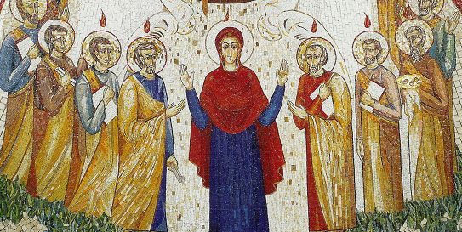
The animator may now invite to turn the sharing and the listening into a spontaneous prayer. He may begin, just to set the tone of the prayer and to help others, especially those who are not used to praying aloud or in public, to formulate their own prayer.
Concluding song
It may be either a meditative or a joyful song that takes up the theme of the meeting, i.e. the Magnificat or the Oblate “Salve Regina” or any other song that helps the community feel protected and guided by the maternal love of Mary, our common mother.

