21.

Apostolic Community engenders life: Vocations
Setting – Hymn
Someone prays in invitation to Jesus to be present here at this gathering.
Introduction
This is a proposal for the last “faith sharing encounter” of the first year of our Oblate triennium. It helps us connect and prepare for the beginning of the second year, whose theme is formation.
Motivation (to be read meditatively): Some are of the view that the Religious life is in a real crisis as many Religious congregations experience a rapid decline in numbers while in some parts of the world finding young vocations has become a luxury. Is the Religious life at the threshold of a “natural death”? What is the main crisis we face in this sophisticated 21st century? Is it quantity or quality? The value and the need for the apostolic communities in the world would never abate if we unearth the real meaning of Religious Life. Let us turn towards the Holy Scriptures to be inspired by the Word of God.
The Word of God (Acts 6:1-7)
Now in these days when the disciples were increasing in number, a complaint by the Hellenists arose against the Hebrews because their widows were being neglected in the daily distribution. And the twelve summoned the full number of the disciples and said, “It is not right that we should give up preaching the word of God to serve tables. Therefore, brothers, pick out from among you seven men of good repute, full of the Spirit and of wisdom, whom we will appoint to this duty. But we will devote ourselves to prayer and to the ministry of the word.” And what they said pleased the whole gathering, and they chose Stephen, a man full of faith and of the Holy Spirit, and Philip, and Prochorus, and Nicanor, and Timon, and Parmenas, and Nicolaus, a proselyte of Antioch. These they set before the apostles, and they prayed and laid their hands on them. And the word of God continued to increase, and the number of the disciples multiplied greatly in Jerusalem, and a great many of the priests became obedient to the faith.
Silent reflection
A Short Reflection: It is not so much what we do that will attract people, but rather it is what we are. That is exactly what happened in the first Christian community. The way they handled a real problem, how they truly carried a witnessing value, as well as the way they listened, respected and cared for one another must have passed on a powerful message even to the non-believers. As a result, the number of disciples multiplied greatly in Jerusalem (v.7). The core of religious life is community. Therefore by being true witnesses of love, sharing and forgiveness, especially in apostolic communities, we can be ‘signs of contradiction’ to the world. That and only that will imprint our identity as Religious and also bring in more vocations in this fast changing world.
Think a minute. “The purpose of the religious life is to help the members follow Christ and be united to God through the profession of the evangelical counsels. It should be constantly kept in mind, therefore, that even the best adjustments made in accordance with the needs of our age will be ineffectual unless they are animated by a renewal of spirit. This must take precedence over even the active ministry.” (Perfectae caritatis, 2e).
Going deeper into the Theme
… Vocations must always remain a priority if, as a Congregation, we want to stay young, creative, daring, acting with the dynamic power of faith in a style unceasingly renewed.
The Congregation’s future will be that of the young, of the novices and scholastics of today, of all the young men whom the Lord will send us. This future, however, is also in your hands, in the hands of all the Oblates of today, whatever their age or their ministry may be. Our task is to transmit to future generations, in all its purity and with a great spirit of openness and welcome, the heritage we have received from those who went before us. … Young men are, and will always be, interested in a life-ideal like this [inspired by our Constitutions]. But they demand that it be genuinely lived by those who profess it, and not that it be merely written down in their Rule Book. While we may not all be directly involved in vocation work, we are, all of us, by the witness we bear, partly responsible for young men coming to us or avoiding us. Different factors are relevant in this matter; nevertheless, a Congregation which ceases to attract vocations must always question itself about its manner of life and about the quality and dynamism of its missionary action. (To the General Chapter, Rome, December 8, 1980)
… Pursue with confidence and tenacity the work undertaken to promote vocations and to assure the quality of first and ongoing formation. For us, this is vital. If there are no new candidates to join us and persevere with us, there is no future for our Congregation. In his day the Founder invited the Fathers and Brothers to pray to the Blessed Virgin for this intention. This we still have to do today; but we have to do more than that: just like the Founder did, we have to work hard for vocations and not be afraid to invite and call. «Come and see!». – «Come and follow me!». Each Oblate should be able to say this. (To the Oblates of the United States, San Antonio, October 12, 1979)
… As long as the Christian spirit will exist among people, some of them will hear the call of Jesus Christ to follow him in a radical way by committing themselves to the evangelical counsels and by the total gift of their lives to serving the poor. If the Oblates stay vigorous enough and holy enough to answer the needs of these people, they will have disciples and novices. As Paul VI told us in 1974: «Our world more than ever needs preachers, qualified spiritual animators and missionaries who are totally available».
If we can produce today the kind of men we did in the past, we have nothing to fear, we can look ahead to the future with confidence. (To the members of the Provincial Councils in the United States, Belleville, December 4, 1981)
(F. Jetté, Letters to the Oblates of Mary Immaculate, Rome 1984, p. 84. 87-88; 188; 193-194)
Faith Sharing
Today religious life has been questioned. Many people who are not religious are living the Gospel better than many of us who profess to live the Gospel life.
- What relevance has our Religious life for the life of the poor?
- What do we represent for them?
- How can we live the radicality of the Gospel in a world where it seems there is no place for such radicality?
- Do we need a renewal: renewal of our communities and of our ministries?
Commitment
- Our challenge today is to create a culture of vocation in home, church and school that will encourage and assist our young members to respond to God’s call.
- We promote nurturing marriage and single life, how can families and parishes help to nurture vocations to priesthood and religious life?
- Today, despite declining numbers and advancing age, men and women religious can be found starting new ministries among the most desperate and forgotten of peoples: immigrants, the homeless, the mentally ill, persons with HIV/AIDS, drug addiction, and so on. Their life commitment not only supports but also encourages a deep availability to serve Christ in the poorest of the poor. The Oblate needs to be engaged in special ministries that attract the young to be committed.
- What characteristics will be needed by our future generations of priests and religious? For whom would a religious vocation be a viable life choice?
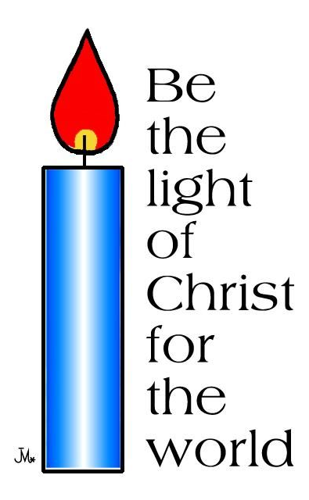
- Today’s religious and priests need to be flexible enough to flow with the changes that characterize this time in the history of our Church and world. They also need to be adventuresome enough to risk in order to help create the priestly or religious life of the future.
- Finally, vocation discernment needs to be an integral part of the faith formation of youth, everywhere. Moreover, parental attitudes towards priesthood and religious life can determine whether or not those life choices make it onto a young person’s outlook/mentality.
Intentions – Final Prayer – Blessing and Song

