6.

Relationship between
Apostolic Community and Mission

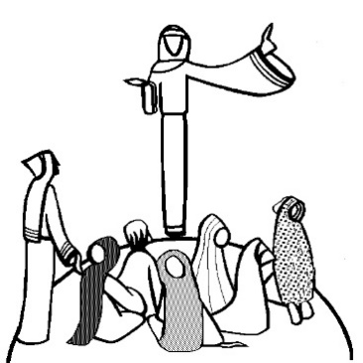
Setting

Hymn

Motivation
We are an Apostolic Community on Mission with the Life Giving and Transforming Message of Jesus Christ: “Leave nothing undared for the Gospel” (St. Eugene de Mazenod)
Like St Eugene de Mazenod, we gather around the person of Jesus Christ so as to achieve solidarity of compassion, to become a single heart that can be food for the life of the community. We choose to live in community as a way to be continually evangelized, and to witness to the Kingdom of God in this graced moment of history.
Recognizing that what we dream alone will remain always just a dream, but what we dream with others can become reality, we acknowledge the limits of the individual and the value of community.
Happiness is only real when it is shard in community. The vision is only real when shared – is what the long and full life of Eugene De Mazenod led him to discover, and to invite others to share. Community is all about VISION – a shared vision!

The Word of God (Mc 3:13-19)
He went up on the mountain and summoned those whom He Himself wanted, and they came to Him. He appointed twelve, so that they would be with Him and that He could send them out to preach, and to have authority to cast out the demons. He appointed the twelve: Simon (to whom He gave the name Peter), and James, the son of Zebedee, and John the brother of James (to them He gave the name Boanerges, which means, “Sons of Thunder”); and Andrew, and Philip, and Bartholomew, and Matthew, and Thomas, and James the son of Alphaeus, and Thaddaeus, and Simon the Zealot and Judas Iscariot, who betrayed Him.

Oblate text
Community and Mission: We fulfil our mission in and through the community to which we belong. Our communities, therefore, are apostolic in character. … By growing in unity of heart and mind, we bear witness before the world that Jesus lives in our midst and unites us in order to send us out to proclaim God’s reign (C 37).
St. Eugene writes to the community of Notre-Dame de L’Osier: “If one can find in your house no more than a group of priests living under the same roof, as pastors from the surrounding neighborhood might do, you will be guilty before me, before the Congregation and before God; and the people for whose sake you surrendered your Oblate way of life will go away but little edified and certainly deceived in their expectations” (Letter to Father Guigues, October 8, 1835: Oblate Writings, I, vol. 8, no. 547, p. 198).

Reflection and Sharing
Community for Eugene makes no sense unless it is born from a shared vision. The vision involves “seeing” at several levels:
- We come together because we have seen the Lord (John 20:18, 25)
All members of this family are brought together because, like Eugene, we have allowed ourselves to be touched by the loving look of the Savior and His call to bring others to relate to Him in the same way. This is the basic foundation of our community: we are a group of people who come together so as to make actual the promise that “where two or three are gathered in my name, I am there among them” (Mt 18:20).

- We come together as a family that invites others to come and see the same Lord with us (Jn 1:39)
Today we understand mission as going to those who are abandoned – to be with them and to enter into a process of mutual enrichment by listening and by sharing our own lived experience of living as a community loved by God. In sharing our own experience we invite them into the larger community of the Mazenodian family – of those throughout the world who, in varying degrees, are touched by the Vision and form one big community looking together at the One who makes us free.
- We come together because we recognize the face of Savior in those who are abandoned today (Mt 25:40)
Our specific Missionary Oblate identity is essentially linked to community. If we were to lose community, we would no longer be Oblates. What makes us different, makes us Oblates is not just that we have individually heard a call but that we have been “drawn together, ” by the “call of Jesus Christ” (C. 1). Therefore we find apostolic community quite an important issue to discuss; it is a non-negotiable element on which our future as Oblates depends (Wilhelm Steckling, Apostolic Community, OMI Documentation, No. 282, April 2008).

Suggestions
Do we still show that we have been “drawn together” like this? Do people notice it?
YES, we still do show who we are – our famous family spirit is often noticed by people as something unique. Our fraternal bonding has remained strong; Oblates are generally happy and proud of bearing that name
NO, we don’t. We don’t make it clear enough that we were drawn together as a community. There are situations where a full community life, beyond the social gatherings on feast days, does not really exist.

Final Prayer
Eternal and merciful God,
Who, in your universal plan of salvation,
wish that all men
come to the knowledge of the truth,
we give you thanks that you have given the world
your only-begotten Son as our Master and Redeemer,
R. Praise to you Lord, from all the earth.
You Who have sent Jesus Christ
to bring the Good News to the poor,
and to prisoners freedom,
help us to make our community ever more missionary,
so that we may welcome men of every tongue and nation, R.
You Who call all peoples
out of darkness to your wonderful light,
so that every knee in heaven,
on earth and under the earth,
might bend the knee at the name of Jesus,
make us cooperators and witnesses of the Gospel, R.
Give us an upright and sincere heart
open to welcome your Word,
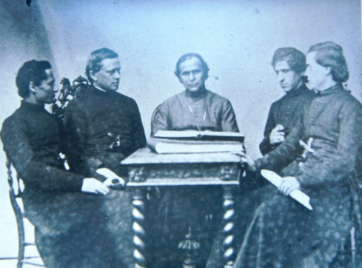
and bring forth abundant fruit of holiness in us
and in the whole world. R.
May the voice of Christ find an echo in our words, so that all who hear us may be brought to the obedience of the Gospel. Pour out your Holy Spirit into our hearts, so that, being all things to all men, we may bring to you, O Father, a multitude of children, who, in your holy Church, will praise you forever. Amen.

