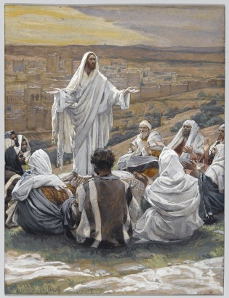
2.

Jesus praying with his Disciples
1. SETTING
All can be seated around a small table which has a lighted candle, a Holy Bible and an Oblate Cross on it. (you may use any symbol which would be appropriate for your context)
2. Motivation
A missionary is not a silent witness. Community has an apostolic orientation. Jesus set up around his person a community of disciples to found a new Israel (1972 General Chapter on “Community”, 9).
Man by his very nature is a social being. He cannot but communicate himself with others. Millions and billions of social interactions take place around the globe each and every day, and therefore no one would dare to deny the fact that the world, after all, is one single community. We have peace, if only we have real communion with one another. Jesus was in communion with the twelve, his immediate “community”. Let us try to focus our attention to Jesus Christ our Lord and Master in order to draw inspiration and meaning to our community life.
3. HYMN
4. Prayer
5. THE WORD OF GOD (John 17:11-19)
And I am no longer in the world, but they are in the world, and I am coming to you. Holy Father, keep them in your name, which you have given me, that they may be one, even as we are one. While I was with them, I kept them in your name, which you have given me. I have guarded them, and not one of them has been lost except the son of destruction, that the Scripture might be fulfilled. But now I am coming to you, and these things I speak in the world, that they may have my joy fulfilled in themselves. I have given them your word, and the world has hated them because they are not of the world, just as I am not of the world. I do not ask that you take them out of the world, but that you keep them from the evil one. They are not of the world, just as I am not of the world. Sanctify them in the truth; your word is truth. As you sent me into the world, so I have sent them into the world. ¹⁹ And for their sake I consecrate myself, that they also may be sanctified in truth.
6. Time for silent reflection
Jesus chose a group of disciples for Himself right at the beginning of his Galilean ministry (Mark 1:16). He never wanted to go about doing preaching and healing all alone. More often than not, Jesus accompanied them to wherever he went. In fact He called them His “friends” (John 15:15) specifically to reiterate how close He was to them. Here, Jesus not only prays with the disciples, He prays for them so that they also may be one as He and the Father are one. Is this not a confirmation that Jesus wants us also to be praying communities who always strive to be one? Are we praying for and strengthening each other in their worries, struggles and celebrate their joys?
7. RESPONSE TO GOD’S WORD
8. OBLATE TEXTS
… We must be filled with our spirit and live only by it. This is self-evident without it being necessary to explain it. Just as we have in a Society a common dress, common Rules, so must there be a common spirit which vivifies this particular body. The spirit of Bernardine is not that of the Jesuit. Ours also is our own. Those who have not grasped this, through not having made a good novitiate, are among us like dislocated members. They make the whole body suffer and are not themselves at ease. It is indispensable that they put themselves back in their place.
Art. 1. Charity is the pivot on which our whole existence turns. Art. 2. That which we ought to have for God makes us renounce the world and has vowed us to his glory by all manner of sacrifice, were it even to be our lives.
Art. 3. It is in order to be worthy of this God to whom we are consecrated that we have vowed to renounce ourselves by obedience, riches by poverty, pleasures by chastity.
(I have no complaint about this last article. I have little to say about the second, but the first is not understood by certain individuals. Whence the disorders that I have had to deplore. Let us not cease to meditate on this point that is so important; that we are not religious by observing it as badly as we have up to now).
Charity for our neighbour is again an essential part of our spirit. We practice it first amongst us by loving each other as brothers, by considering our Society only as the most united family which exists on the earth, by rejoicing over the virtues, the talents and other qualities that our brothers possess just as much as if we possessed them ourselves, in bearing with mildness the little faults that some have not yet overcome, covering them over with the mantle of the most sincere charity, etc.”. (Letter to Fr. Guibert at Notre Dame du Laus, 29.7.1830)
The community of Aix was a real family. The all lived the same life and every heart blossomed under the rays of the same sun. They were all, as it were, continually warmed by the affection of a father whose attention for them all was something that nothing greater could be imagined. The “cor unum et anima una” that the Founder recommends in the Rules as one of the characteristics of his Congregation, was really the distinctive sign of that little community which was searching, in the midst of a thousand external difficulties, to put down its first roots, in order to raise itself to the point to which God would be pleased… The members of that little family, closely tied around their superior as chicks under the wings of the mother hen, offered a moving spectacle regarding the bonds of love that united them to their superior and to each other. They were really the image of the first Christians, as it is shown in the Acts of the Apostles. There was no rivalry, nor self-searching, no prejudices regarding others, but rather the joy and almost the pride in the successes of a brother… In short, it was the most perfect communion of saints. (Bishop Jeancard, Mélanges Historiques, p. 26-29)
9. GOING DEEPER INTO THE THEME
Fr. Beaudoin makes this relationship between community and mission clear when de Mazenod speaks of the Rule of 1818: “If we examine these articles of the Rule in the light of the Founder’s letters, the importance of community is beyond any shade of doubt. Oblates seek sanctity together, pray together, do the work of evangelization together. The whole second part of the Rule makes explicit the communitarian striving towards perfection so that the ministry, which also is carried out in community, should, by the blessing of God, become fruitful. In the sixth paragraph which treats of the various ministries, the Divine Office which all the Oblates must recite in common is even presented in this light: «The Institute considers this exercise as the source of all blessings which are to be poured over the entire holy ministry in the length and breadth of the Society»”. (Community and Mission according to Bishop de Mazenod and according to the First Generation of Oblates in Europe, « Vie Oblate Life », 49, 1990, p. E 182)
See also Francis Kelly Nemek, omi., Prayer-Oraison, “Dictionary of Oblate Values”, Rome 2000, p. 733-747 (especially 746-747).
10. FAITH SHARING
– What priority does Community have in the hierarchy of my values? (cf. WAC 23,1)
– Do we mature in responsibility for each other? Do we become more transparent to each other? Do we learn to share in depth our personal histories, missionary ideals, and lives of faith?(
– Does our community have a common missionary project? Can we develop one?
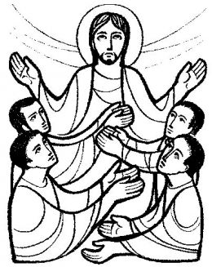
– Do I play my part in implementing the missionary enterprise of the community?
11. COMMITMENT
What God wants us to do
– as a person and as a community?
INTENTIONS
12. FINAL PRAYER
13. BLESSING AND A SONG

