3

Jesus shares his life with the Apostles in Eucharist
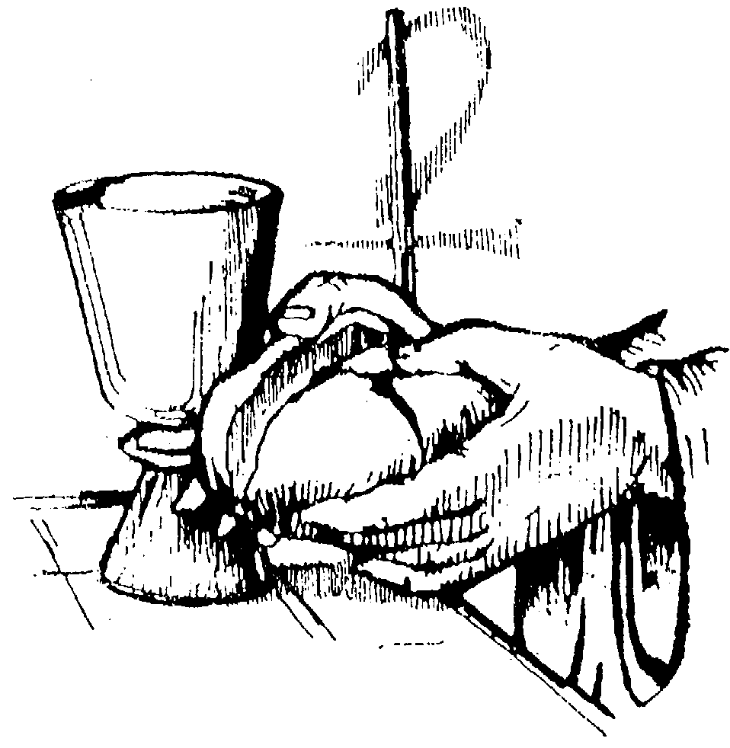
1. Setting
Prepare the place where the community is going to meet. Put on a well prepared table the Eucharistic symbols (a loaf of bread, a chalice or a cup of wine, wheat or grapes, etc.)
2. Introduction
3. Hymn
Begin with a song highlighting the event or the meaning of the Eucharist: the last supper, the gift of life…
4. Prayer
5. The word of God (Mat 26:20.26-32)
Now when evening had come, He was reclining at the table with the twelve disciples. … And while they were eating, Jesus took some bread, and after a blessing, He broke it and gave it to the disciples, and said, “Take, eat; this is My body.” And when He had taken a cup and given thanks, He gave it to them, saying, “Drink from it, all of you; for this is My blood of the covenant, which is poured out for many for forgiveness of sins. “But I say to you, I will not drink of this fruit of the vine from now on until that day when I drink it new with you in My Father’s kingdom.” And after singing a hymn, they went out to the Mount of Olives. Then Jesus said to them, “You will all fall away because of Me this night, for it is written, ‘I will strike down the shepherd, and the sheep of the flock shall be scattered.’ “But after I have been raised, I will go before you to Galilee.”
6. Time for silent reflection
7. Response to God’s Word
8. Oblate Texts
– From our Constitutions and Rules
The Eucharist, source and summit of the Church’s life, is at the heart of our life and action. We will live such lives as to be able worthily to celebrate it every day. As we participate in its celebration with all our being, we offer ourselves with Jesus the Saviour; we are renewed in the mystery of our cooperation with him, drawing the bonds of our apostolic community ever closer and opening the horizons of our zeal to all the world. In gratitude for this great Eucharistic gift, we will seek the Lord often in his sacramental presence. (C 33)
– From the writings of Eugene de Mazenod
Whatever your occupations may be, never fail to make your morning and evening meditations, never abstain from saying your Mass, whatever pretext may present itself: the wrong you would do to yourself and to the Church, the glory which you would withhold from God, and all the other reasons which you know, and which it is useless for me to adduce here, oblige me to make this a duty of conscience for you. To act otherwise, would be to depart entirely from the spirit of our Institute, and from what has been constantly practiced in it. … I content myself with transcribing the words of the Rule: «Everyday they must be careful to celebrate the most Holy Sacrifice of the Mass; and if, during a journey, when several Missionaries travel together, there is no possibility of all saying Mass, but if all cannot possibly celebrate, one at least shall enjoy this privilege, the others communicating within that Mass; nevertheless, every exertion must be made, in order that the Missionaries may not be deprived of the precious fruit of the M. Holy Sacrifice, abstaining from It, only in the case, in which nothing better can be done.» …
I insist on this point, because to my great astonishment, I met some of our Fathers capable of this unpardonable sloth, a real infraction of one of our most essential Rules, and this, perhaps, from having seen other Priests make no difficulty in omitting Mass when, to say it, would cost them a little trouble. I am confirmed in my supposition, from its having been my lot to meet with a Priest, otherwise good, who unceremoniously said to me, in a religious house, in which I was going to say Mass, as well as the Fathers who accompanied me: « Tomorrow, I shall take a little repose. » This did not mean that he would rise later, for he attended me; but simply that he would not give himself the trouble of saying Mass. It is the repetition of similar examples, under the eyes of our Fathers in England, which might induce them to contract evil habits, against which it is my duty to engage with the « strong one armed »; in one of his formidable strongholds, and that you need nothing less than the strength of God Himself, to triumph over this powerful enemy. And whence will you draw the strength, but from the Holy Altar, and from Jesus Christ your Head? Our devotion towards His Divine Person ought to be the more lively, that we have, before all, to repair the outrages which He has received in this land wherein you dwell, and to atone to Him, for the impious and insolent revolt, in which this strayed people still persevere; refusing to adore Him in this Sacrament of His love for men. Let this spirit of reparation, therefore, animate us constantly, let it inflame our souls, let it inspire us always to leave nothing undone; 1st to offer Him ourselves, as it were, a holocaust and to bring back to Him as many as possible of the strayed souls.
Act of Visitation of the Province of England, July 22, 1850
9. Going deeper into the Theme – A commentary by Fr. Jetté
The Eucharist is the Oblate’s first activity. He places it “at the heart” of his “life and action”. This paragraph takes much of its inspiration from the teaching of our Founder and from Vatican Council II. The Council states that the Eucharist is “the source and summit of all preaching of the Gospel. […] In the most blessed Eucharist is contained the whole spiritual good of the Church, namely Christ himself our Pasch and the living bread which gives life to men through his flesh – that flesh which is given life and gives life through the Holy Spirit. Thus men are invited and led to offer themselves, their works and all creation with Christ” (Presbyterorum ordinis, no. 5). It was the Founder’s will that Oblates “live such lives as to be able to celebrate it (the Eucharist) every day”. He himself insisted a great deal on this point. That is in line with his deep faith. In his Act of Visitation of the Province of England he dwelt on this point [see text quoted above].
For Eugene de Mazenod the Eucharist was also the locus for a daily encounter with his Congregation. In the Eucharist, every morning during Mass and in the evening before Christ in the chapel, he remembered each Father and Brother of his religious family. As he wrote to Father Lacombe on March 6, 1857: “You could not believe how much I think in the presence of God of our dear Red River missionaries. I have only one way of drawing near to them, and that is in front of the Blessed Sacrament, where I seem to see you and to touch you. And you for your part must often be in his presence. It is thus that we meet each other in that living centre which serves as our means of communication” (Selected Texts…, no. 267). An expression is often found in his writings: it is before the Blessed Sacrament that he finds in Jesus Christ a “common centre”, a “living centre” wherein he meets with all the Oblates and he invites the latter to do the same (cf. Selected Texts…, nos. 261, 263, 265, 267, 268). In the sentence that follows the article states the dispositions of our participation in the Eucharist and lists the results that ought to spring therefrom. Oblates take part in the celebration of the Eucharist “with all their being”, that is to say, as attentively and intensely as they are able – it matters not at all whether they are Brothers or Fathers – and they offer themselves “with Jesus the Saviour”, that is to say, to be his co-workers in saving the world and even victims together with him, if necessary, to redeem it. How many Oblates have borne and still bear each day in the Eucharist the needs, miseries and joys of people! The article lists three things that result to us from the Eucharist: 1) Oblates are “renewed in the mystery of our cooperation with [Christ]; 2) “the bonds of our apostolic community” are drawn ever closer; 3) “the horizons of our zeal” are opened up to all the world. Thus in the Eucharist Oblates find affirmation of their proper vocation as co-workers with Christ, apostolic men and universal missionaries. The article’s last sentence is entirely in keeping with the Oblate tradition: besides the celebration of the Eucharist and the evening oraison, Oblates “will seek the Lord often in his sacramental presence.” That is why in every Oblate house there is to be a chapel where the Blessed Sacrament is kept. As the Founder wrote: “I have told Father Vincens that I consider it indispensable that you arrange in your house a chapel where the Blessed Sacrament may be preserved. Our evening oraison must definitely be made in the presence of our Lord, and we must be able easily to visit him often during the day. This would be impossible if we had to go to a public church” (Letter to Father Delpeuch, December 10, 1856, in Selected Texts…, no. 266)
(F. Jetté, OMI The Apostolic Man. A commentary on the 1982 edition
of the Oblate Constitutions and Rules, Rome 1992, p. 193-197)
See also: F. Ciardi, The Eucharist in the Life and Thoughts of Eugene de Mazenod, «Vie Oblate Life», 38 (1979), p. 201-231.
Pause for reflection
It may now be good to invite those present to pause for a few minutes, in meditation of what has been read and preparing to share their own experience.
10. Sharing
The animator of the meeting may now invite those present to pause for a few minutes in meditation of what has been read and to prepare for sharing their own experience around the theme of the Eucharist, especially connected with the reality of our community life. Here are a few points that can guide and help the sharing.
- What has been your relationship with Jesus in the Eucharist before joining the Oblates? You may also go back to your infancy years, to your family experience, maybe a recollection of your first holy communion…
- What has been your relationship with Jesus in the Eucharist within the Oblate life and family? You may want to share how you live such relationship today, maybe telling a story, an experience…
- Could you share an experience where your community life has been helped and sustained by the Eucharist? Or an experience where through your love for the Eucharist you were able to help your brother in a particular situation?
- Anything else you would like to share about the theme of this community meeting.
11. Commitment
12. Common spontaneous prayer
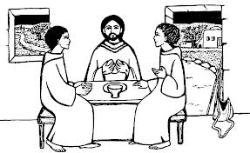
The animator may now invite to turn the sharing and the listening into a spontaneous prayer. He may begin, just to set the tone of the prayer and to help others, especially those who are not used to pray aloud or in public, to formulate their own prayer.
13. Blessing and final song
The final song may take up a theme that has come out during the meeting, a song to our Lady (i.e. the Oblate “Salve Regina”) or any other song that helps the community tighten the bonds of love, friendship and unity.

List of the Faith Sharing Encounters
Jesus and the community of the Apostles: Jesus as our Center
Jesus praying with his Disciples
Jesus is abandoned by his apostles
Jesus shares his life with the Apostles in Eucharist
Jesus gives his life on the Cross
The community of the first Christians
St Eugene calls together companions
The new community: what joy!
The challenge of Perseverance in the first companions
Relationship between Apostolic Community and Mission
St Eugene calls Oblates to have one heart and one soul
Eugene bequeaths charity for his Oblates
Oblate Mission is lived in and through Community
Apostolic community: a place for mutual acceptance and accountability
Apostolic community is witness, evangelization by lived example
Mary Immaculate is Mother of the Apostolic Community
Apostolic Community generates
right relationships with God, self, others, creation
Apostolic Community connects us
to the poor and calls us to live a simple and poor life
Apostolic Community is Missionary
Apostolic Community is a community of brothers who serve
Apostolic Community is prophetic
Apostolic Community engenders life: Vocations
Apostolic Community consists of Brothers and Priests
Apostolic Community has a vital relationship with the laity

