1.

Jesus and the community of the Apostles:
Jesus as our Center
1. Setting
The animator of the encounter arranges the ambience so that all may be comfortably seated in a circle to facilitate prayer and discussion. A candle, the Bible, an Oblate Cross may be placed in the center.
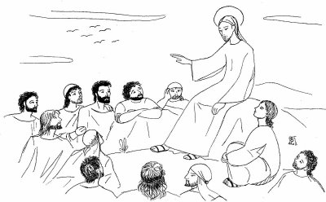
2. SONG
3. MOTIVATION
A few words to animate those participating are made by the animator.
We want to become aware that our community exists because each one of us has been called personally by Jesus and because we want to follow him together. He is the center of our community and the bond that unites us.

4. Prayer

5. THE WORD OF GOD

The Twelve Are Chosen: Mark 3:13-19
And He went up on the mountain and summoned those whom He Himself wanted, and they came to Him. And He appointed twelve, so that they would be with Him and that He could send them out to preach, and to have authority to cast out the demons. And He appointed the twelve: Simon (to whom He gave the name Peter), and James, the son of Zebedee, and John the brother of James (to them He gave the name Boanerges, which means, “Sons of Thunder”); and Andrew, and Philip, and Bartholomew, and Matthew, and Thomas, and James the son of Alphaeus, and Thaddaeus, and Simon the Zealot; and Judas Iscariot, who betrayed Him.

6. Time for silent reflection

7. RESPONSE TO GOD’S WORD: a song or psalm may be sung or recited.
8. OBLATE TEXTS

Witnessing as Apostolic Community # 6. 8. 10: p. 21-23 (English Edition)
6. “Like our Founder before us, we seek to gather around the person of Jesus Christ so as to achieve solidarity of compassion, to become a single heart that can be food for the life of the world…
8. “It is not primarily for its own sake, then, that our common life exists: it is flesh for the life of the world. The community we create together around Jesus Christ is the banquet table to which we invite mankind…”
10. “The community of the Apostles around the person of Jesus is the model for our life together. The person of Christ unites us in charity and obedience; this enables us to live again the communion of life and the common mission in his Spirit that the Twelve Apostles shared with him (C. 3). From this perspective, it is clear that the objective of community is much more than merely gathering a group that functions well together; its aim is to establish interdependence and profound communion between its members.”

From: The Apostolic Man, by Father Jetté:
“For Eugene de Mazenod the Eucharist was also the locus for a daily encounter with his Congregation. In the Eucharist, every morning during Mass and in the evening before Christ in the chapel, he remembered each Father and Brother of his religious family. As he wrote to Father Lacombe on March 6, 1857: ‘You could not believe how much I think in the presence of God of our dear Red River missionaries. I have only one way of drawing near to them, and that is in front of the Blessed Sacrament where I seem to see you and touch you…An expression is often found in his writings: it is before the Blessed Sacrament that he finds in Jesus Christ a ‘common centre’, a ‘living centre’ wherein he meets with all the Oblates and he invites the latter to do the same.” (p. 195)
9. GOING DEEPER INTO THE THEME
- Motte, René, Jesus forming the Apostles, «Vie Oblate Life» 46 (1987), p. 3-25.
- Jetté, Fernand, Jésus Christ, in Dictionnaire des Valeurs Oblates, Rome 1996, p. 466-492.
10. SHARING OUR FAITH
- Do you experience that we are gathered around Jesus? In what ways?
- How is the community of the Apostles around the person of Jesus a model for our life together?
- When have you experienced “profound communion” among us as an Oblate?
- How can we deepen our communion as brothers around the Lord?
The animator invites each person present to pray, to thank God for something, someone and to ask for whatever might be needed.

11. COMMITMENT: A SIGN OF CONVERSION
The animator reminds everyone that we are preparing for the Triennium by seeing how we can grow, change, be transformed. We are asked to consider a concrete gesture in the life of our community as a sign of conversion. Let us ask God to inspire us, help us be bold and courageous so that during these weeks and months of preparation we will commit ourselves to some real signs of new life among us.

12. PRAYER AND THANKSGIVING
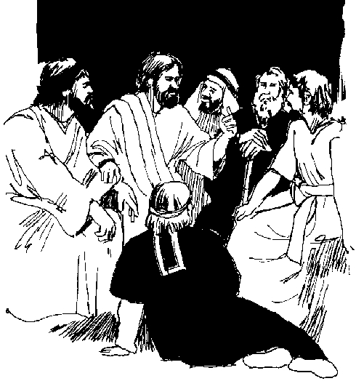
13. BLESSING AND FINAL SONG

